**ELCN8005-21F-Sec1-Electronics Design Principles**

* **Experiment:** Unregulated Power Supply
* **Submitted by:** 
  + - **Name:** Naren Subburaj
    - **Student number:** 8772452
* **Date:** 16/11/2021

**OBJECTIVE:**

Design and build an Unregulated Power Supply and Regulated Power supply

**EQUIPMENTS:**

|  |  |
| --- | --- |
| **Hardware** | **Software** |
| LM348 – 1  Capacitor – 1uf  Power supply – 9v  Diode - 4  Multimeter – 1  Breadboard – 1 | Multisim |

**SCHEMATIC IN MULTISIM:**

**Unregulated power supply:**

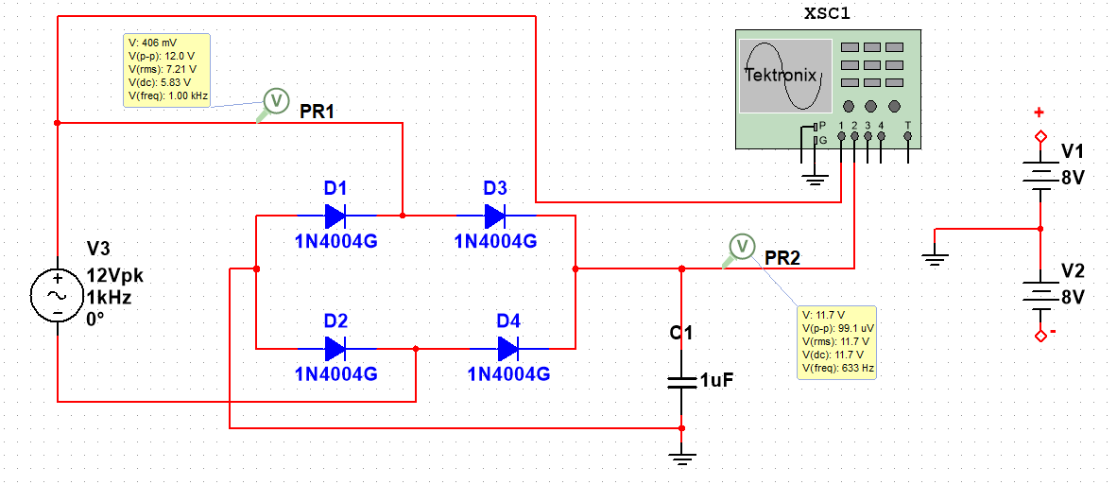

**Regulated power supply:**

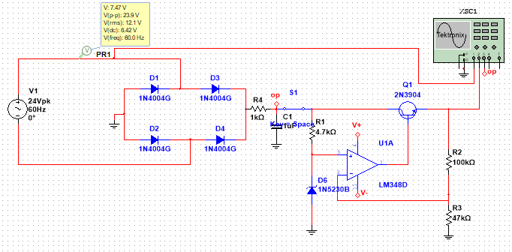

**Optocoupler:**

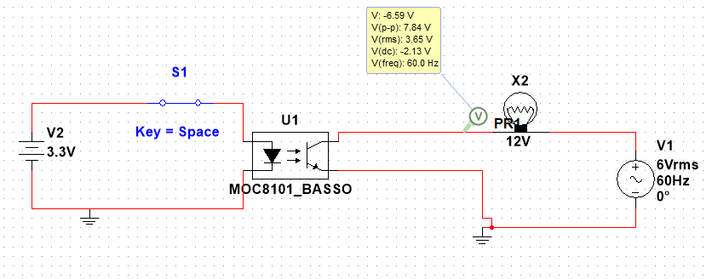

**OUTPUT:**

**Unregulated power supply:**

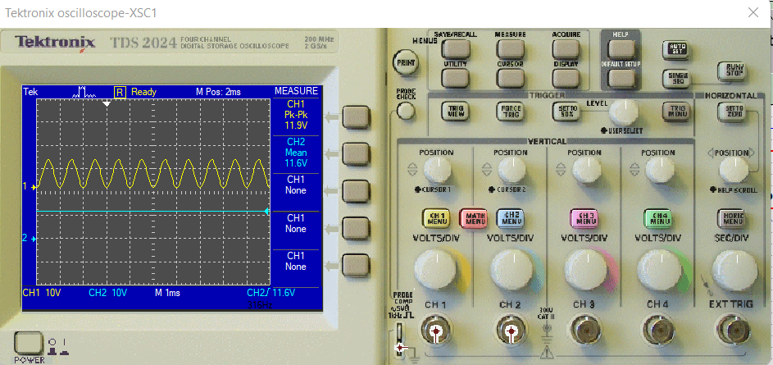

**Regulated power supply:**

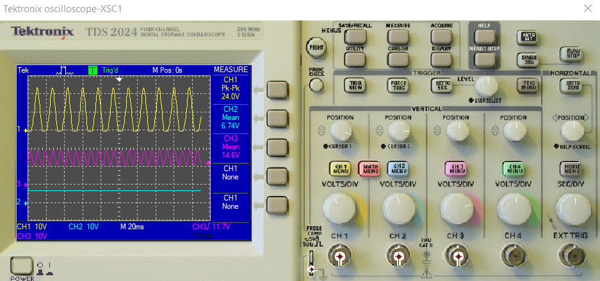

**Optocoupler:**

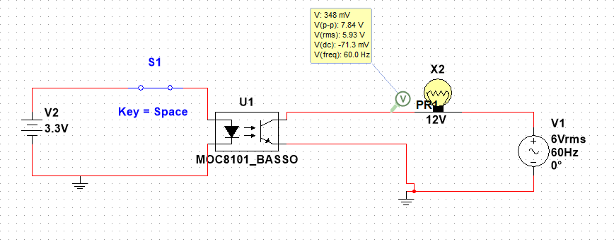

**CALCULATIONS:**

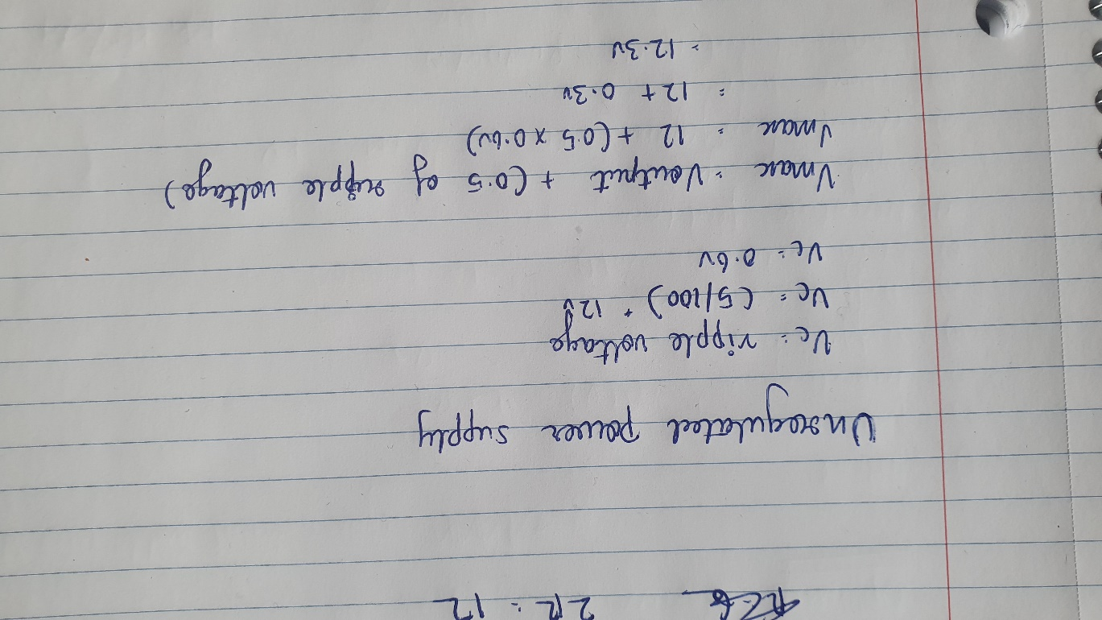

**THEORY VS PRACTICAL:**

**Unregulated power supply:**

|  |  |  |
| --- | --- | --- |
| **Theory Voltage** | **Practical Voltage** | |
| **Multisim** | **Breadbroad** |
| 12.3 v | 11.6v | 11.8v |
| **Regulated power supply:** |  |  |
| **Theory Voltage** | **Practical Voltage** | |
| **Multisim** | **Breadbroad** |
| 12v | 6.7v | 6.4v |
| 18v | 6.5v | 6.5v |
| 20v | 6.7v | 6.8v |

**CONCLUSION:**

The unregulated power supply where the input ac signal is converted into dc signal. As its unregulated power supply if the input changes the output voltage also varies.

The regulated power supply where the input ac signal is converted into dc signal without fluctuation. Even if the input voltage is changed output remains constant.

**DISCUSSION:**

From performing this experiment, I am able to build the unregulated and regulated power supply circuit in multi sim and breadboard. Understood the working principle of the VCO.

**Reference:** https://www.electronics-tutorials.ws/blog/unregulated-power-supply.html